There are many different formats and styles that can be used to effectively document business processes. The following provides examples of formats and an outlines of the most commonly used symbols.

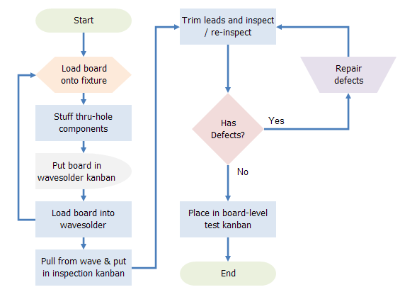

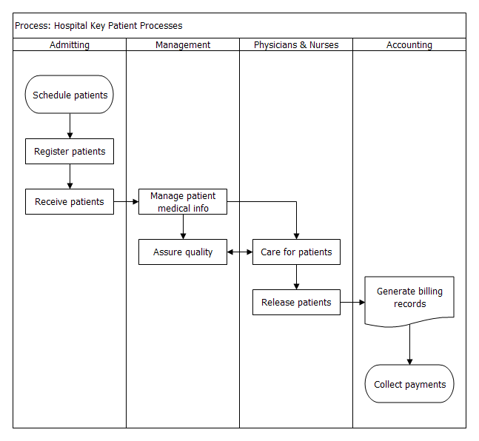
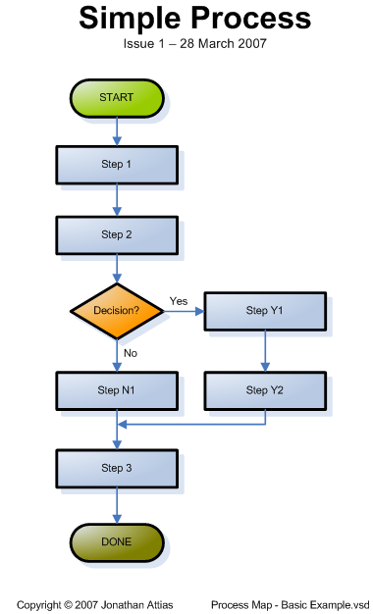
Symbol | Symbol Name  (Alternate Shape Name) | Symbol Description
 | Terminator  (Terminal Point, Oval) | Terminators show the start and stop points in a process. When used as a Start symbol, terminators depict a trigger action that sets the process flow into motion.
 | Process | Show a Process or action step. This is the most common symbol in both process flowcharts and business process maps.
 | Predefined Process  (Subroutine) | A Predefined Process symbol is a marker for another process step or series of process flow steps that are formally defined elsewhere. This shape commonly depicts sub-processes (or subroutines in programming flowcharts). If the sub-process is considered "known" but not actually defined in a process procedure, work instruction, or some other process flowchart or documentation, then it is best not to use this symbol since it implies a formally defined process.
 | Alternate Process | As the shape name suggests, this flowchart symbol is used when the process flow step is an alternate to the normal process step. Flow lines into an alternate process flow step are typically dashed.
 | Decision | Indicates a question or branch in the process flow. Typically, a Decision flowchart shape is used when there are 2 options (Yes/No, No/No-Go, etc.)
 | Data  (I/O) | The Data flowchart shape indicates inputs to and outputs from a process. As such, the shape is more often referred to as an I/O shape than a Data shape.
 | Document | Pretty self explanatory - the Document flowchart shape any process flow step that produces a document.
 | Multi-Document | Same as Document, except, well, multiple documents. This shape is not as commonly used as the Document flowchart shape, even when multiple documents are implied.
 | Preparation | As the names states, any process step that is a Preparation process flow step, such as a set-up operation.
 | Display | Indicates a process flow step where information is displayed to a person (e.g., PC user, machine operator).
 | Manual Input | Manual Input flowchart shapes show process flow steps where the operator/ user is prompted for information that must be manually input into a system.
 | Manual Operation | Manual Operations flowchart shapes show which process steps are not automated. In data processing flowcharts, this data flow shape indicates a looping operation along with a loop limit symbol (which is not supported by Microsoft Office, but a Manual Operation symbol rotated 180° will do the trick.)
 | Card | This is the companion to the punched tape flowchart shapes. This shapes is seldom used.
 | Punched Tape | If you're very good at stretching all the life out of a machine, you may still have use for the Punched Tape symbol - used for input into old computers and CNC machines.
 | Connector (Inspection) | Process Flowchart: In process flowcharts, this symbol is typically small and is used as a Connector to show a jump from one point in the process flow to another. Connectors are usually labeled with capital letters (A, B, AA) to show matching jump points. They are handy for avoiding flow lines that cross other shapes and flow lines. They are also handy for jumping to and from a sub-processes defined in a separate area than the main flowchart.  Business Process Map: In process maps, this symbol is full sized and shows an Inspection point in the process flow.  [Just to confuse things further, some people will use a circle to indicate an operation and a square to indicate an inspection. That's why it's important to include a symbol key in the flowchart.]
 | Off-Page Connector | Off-Page Connector shows continuation of a process flowchart onto another page. When using them in conjunction with Connectors, it's best to differentiate the labels, e.g. use numbers for Off-Page Connectors and capital letters for Connectors. In actual practice, most flowcharts just use the Connect shape for both on-page and off-page references.
 | Or | The logical Or symbol shows when a process diverges - usually for more than 2 branches. When using this symbol, it is important to label the out-going flow lines to indicate the criteria to follow each branch.
 | Summing Junction | The logical Summing Junction flowchart shape is shows when multiple branches converge into a single process. The merge symbol is more common for this use, though. This symbol and the Or symbol are really more relevant in data processing flow diagrams than in process flowcharts.
 | Collate | The Collate flowchart shape indicates a process step that requires organizing data, information, or materials according into a standard format or arrangement.
 | Sort | Indicates the sorting of data, information, materials into some pre-defined order.
 | Merge  (Storage) | Process Flowchart: In process flowcharts, this symbol shows the merging of multiple processes or information into one.  Business Process Map: In process mapping, this symbol is commonly indicates storage of raw materials.
 | Extract (Measurement) | Process Flowchart: In my personal experience, I have only seen the Extract flowchart shape indicates a Measurement, with a capital 'M' inside the symbol.  Business Process Map: Often indicates storage of finished goods.
 | Delay | The Delay flowchart symbol depicts any waiting period that is part of a process. Delay shapes are common in process mapping.
 | Stored Data | A general Data Storage flowchart shape used for any process step that stores data (as opposed to the more specific shapes to follow next in this table).
 | Magnetic Disk (Database) | The most universally recognizable symbol for a data storage location, this flowchart shape depicts a database.
 | Direct Access Storage | Direct Access Storage is a fancy way of saying Hard Drive.
 | Internal Storage | Used in programming flowcharts to mean information stored in memory, as opposed to on a file.
 | Sequential Access Storage  (Magnetic Tape) | Although it looks like a 'Q', the symbol is supposed to look like a reel of tap

