A Simple Stakeholder Template for Projects

Project Stakeholders
This document provides a standardised set of headings for use in any style of project documentation. This first section illustrates the structure and gives an example of its use. The second section offers some guidelines. The third section is the template.

Example 'Onion-Rings' Stakeholder Diagram

A Typical Set of Stakeholder Roles

The Onion-Rings Diagram offers a simple way of visualizing a set of stakeholder roles on a project.

The centre is always the equipment ('kit', 'product') in question.

The system or 'work' is always larger than the equipment – in particular, it includes the people who play operational roles, such as the pilots and fitters who carry out normal and maintenance operations on an aircraft. Systems also normally include operational procedures, training manuals and other information as well as the equipment.

Many systems also include maintenance and training kit such as simulators and automated test equipment, and it is important to determine whether these are inside or outside the work boundary.

Outside the work boundary lie the direct beneficiaries of the work. These include those who immediately benefit from the functions carried out by the system (including the operators and the kit). Usually these beneficiaries are different from the operators, but sometimes these roles can be combined, as with home entertainment products such as music players where the operator is also often the person benefiting from using the product.

Further out still are people who are affected indirectly, either deriving benefits such as political gains or financial rewards (e.g. through shareholdings), or suffering harm (having negative stakes) such as the impact of noise, pollution, electromagnetic radiation, loss of amenity, or loss of work.

Roles often involve an element of surrogacy. For example:
- Regulators are typically appointed by government or industry to act as informed surrogates for the public. For example, a health and safety authority monitors and controls industry to ensure practice conforms to standards, and hence minimises risk to both operators and the public. As another example, the international radio regulator creates a framework of rules and assigns radio frequencies to different purposes, so as to minimise electromagnetic interference.
- Purchasing / procurement is generally carried out by a department distinct from operations, and essentially on behalf of both operational and beneficiary roles, whether or not those roles exist at the time the procurement is made.

Surrogate opinions are important, but they are not necessarily equivalent to the views of the people they claim to represent. For instance, it is dangerous for requirements engineers to assume that the viewpoint of a manager corresponds to those of the people – e.g. maintenance operators – being managed.

An Extensible Hierarchy
The purpose of this approach to stakeholder analysis is to help projects pay more effective attention to the roles and viewpoints involved. All domains are different, but some features of stakeholder structure are essentially similar everywhere.

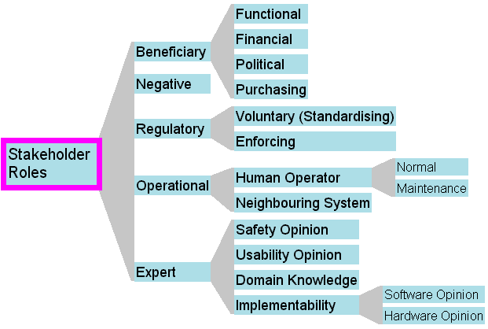
A Simple Classification of Stakeholder Roles
This hierarchy is meant to be extended on specific projects and in specific domains, by splitting (i.e. specialising) the categories to make them easy to understand and to apply.
For example, in the Railway domain, Normal Operators include Train Driver, Line Controller, Station Controller (depending on the specific system you are considering), while Maintenance Operator in general means Asset Maintainer, which can be specialised into Train Maintainer, Track Maintainer, Lift/Escalator Maintainer etc.

Guidelines

Stakeholder Analysis
Fill in the template for your project, using it as a set of general hints to help you discover the key roles and individuals playing those roles. Add table rows for additional stakeholders. Document stakeholders' actual names and their personal viewpoints on the project; if need be, document their roles in more detail, and record their job titles, departments and other clues to their involvement on the project.
Pay special attention to anomalies:
- if any positive role is filled by more than one stakeholder or group of stakeholders, there may be conflicting viewpoints on your project. Take care to discover the different viewpoints, and plan for conflict resolution workshops or other preventative measures. For example, if the Purchasing role is split (procurement is split across more than one agency) then you must ensure there will not be constant debate on acceptance criteria, etc.
- if any role is unfilled on your project, there may be hidden requirements that will not be discovered until late in the project.
- if people are reluctant to discuss an area, this may be because it is known to be dangerous within the organisation. Take care to understand the cause, and find out what kinds of risk it poses to your project.
- if some people say a role is important and some say it is not, this is always significant. Acknowledge the different viewpoints, remain neutral, and make clear that you are collecting viewpoints from all affected stakeholders.
If you find the template does not exactly match the needs of your project – as is likely – then add roles or otherwise modify the template to reflect reality more accurately.

Tool Support
The template can be used directly to analyse stakeholder roles and viewpoints using only a word processing tool, and this immediately provides benefit through increased clarity and reduced risk to the project.
However, where there are many requirements, frequent changes, large or distributed teams, and long projects, word processing alone is not sufficient to manage all the project information, and especially not the traces or links between items such as goals, viewpoints, requirements, and tests essential to ensure that stakeholders get what they need.
Such projects should select a requirements management tool (such as DOORS, Slate, Cradle, Requisite Pro, etc) to enable project engineers to create, maintain, and receive the benefit of a complete and consistent view of project information.
This template is provided in document, spreadsheet, and DOORS Module Archive form to make it easy to apply on all types of project.

Use of Copyright Material
This template may freely be copied and applied on projects, provided it is used as instructed, and provided that its copyright and source are acknowledged. It must not be sold or hired out.

Stakeholder Roles

Beneficiary

Functional Beneficiary
Stakeholder: | Viewpoint:
John Smith | wants to see accurate weekly & monthly sales figures and forecasts

Financial Beneficiary
Stakeholder: | Viewpoint:

Political Beneficiary
Stakeholder: | Viewpoint:

Purchasing
Stakeholder: | Viewpoint:

Negative
Stakeholder: | Viewpoint:

Regulatory

Voluntary (Standardising)
Stakeholder: | Viewpoint:

Enforcing
Stakeholder: | Viewpoint:

Operational Roles

Human Operators

Normal
Stakeholder: | Viewpoint:

Maintenance
Stakeholder: | Viewpoint:

Neighbouring Systems
Stakeholder: | Viewpoint:

Expert

Safety Opinion
Stakeholder: | Viewpoint:

Usability Opinion
Stakeholder: | Viewpoint:

Domain Knowledge (divide this into sub-domains if appropriate)
Stakeholder: | Viewpoint:

Implementability

Software Opinion
Stakeholder: | Viewpoint:

Hardware Opinion
Stakeholder: | Viewpoint:

